

**Software Engineering Project**

Dent-Assist: Dental Clinic Management System

Business Administration Department

Faculty of Economics and Administrative Sciences

Epoka University

01052053 - Ania Keçi

01052075 - Belita Hysaj

01052086 - Idi Xhengo

01052090 - Klea Lala

01052035 – Renis Garxenaj

BINF III / C

03/06/2023

**Table of Contents**

1. Introduction…………………………………………………………………………………
   1. Purpose………………………………………………………………………………….

1.1.1 Manual Record-Keeping………………………………………………………….

1.1.2 X-Ray Management………………………………………………………………

1.1.3 Students…………………………………………………………………………...

1.1.4 Future Prospects………………………………………………………………….

1.2 Document Conventions…………………………………………………………………

1.3 Intended Audience and Reading Suggestions…………………………………………..

1.3.1 Intended Audience………………………………………………………………..

1.3.2 Document Contents and Organization……………………………………………

1.3.3 Reading Suggestions……………………………………………………………..

1.4 Product Scope………………………………………………………………………….

1.4.1 Purpose and Benefits……………………………………………………………..

1.4.2 Alignment with Corporate Goals…………………………………………………

2. Overall Description………………………………………………………………………….

2.1 Product Perspective…………………………………………………………………

2.2 Product Functions…………………………………………………………………..

2.3 Operating Environment…………………………………………………………….

3. External Interface Requirements…………………………………………………………….

3.1 User Interfaces……………………………………………………………………...

3.2 Hardware Interfaces………………………………………………………………...

3.3 Software Interfaces………………………………………………………………….

4. System Features & Functional Requirements………………………………………………..

4.1 Development Model………………………………………………………………..

4.2 Functional Requirements…………………………………………………………..

5. System Features & Functional Requirements………………………………………………..

5.1 Development Model………………………………………………………………..

5.2 Functional Requirements…………………………………………………………..

6. System Design & Modeling………………………………………………………………….

7. Software Maintenance & Evolution…………………………………………………………..

7. Software Testing……………………………………………………………………………...

9. Division of Work…………………………………………………………………………….

10. References……………………………………………………………………..……………

1. **Introduction**

This document is written for the client, the stakeholders of dental clinics that make use of this software, to explicitly describe the management software product that is to be delivered.

* 1. **Purpose**

Many dental clinics in our country nowadays continue to rely on manual record-keeping methods, which can be time-consuming, error-prone, and limit effective workflow management. Acknowledging this difficulty from many first-hand experiences, a web application has been developed with the intention of transforming dental clinic administration systems. This system targets a variety of user roles, including administrators, staff members, patients, and dentistry students who receive hands-on instruction at the clinic. This online application intends to streamline operations, increase efficiency, and improve overall patient care by digitizing critical procedures such as user data management, appointment booking, and x-ray storage.

***1.1.1*** *Manual Record-Keeping*

Despite technological developments, a large proportion of dental clinics still use manual record-keeping methods. These outdated methods require the use of paper-based systems, which can make obtaining and updating patient information challenging. Furthermore, manual appointment scheduling frequently leads to inefficiencies such as multiple bookings or missed appointments. Furthermore, keeping physical copies of patient X-rays and dental data creates storage, retrieval, and archiving issues.

***1.1.2*** *X-Ray Management*

The online application transforms the way dental clinics store and handle patient X-rays. Physical X-ray films have traditionally taken up important storage space and posed risks of loss or damage. Dental clinics may now securely store and view X-ray pictures within the program with this digital solution. Staff members can upload digital X-rays directly into the patient's profile, making them available throughout consultations and treatments. This simplified procedure improves diagnosis accuracy, simplifies treatment planning, and removes the nuisance of physical film handling.

***1.1.3*** *Students*

Many dental clinics function as practical training locations for dentistry students. The web application features a dedicated module that caters to the specific demands of dental students throughout the course of their dentistry practice. The module enables students to access patient information, record treatments, and get instruction and criticism from supervising dentists. This integration supports a more organized learning experience while assuring adequate monitoring and smooth information sharing between students and staff members.

***1.1.4*** *Future Prospects*

The web application's benefits go beyond just making day-to-day operations easier. Dental clinics may improve overall productivity, lower expenses associated with manual record-keeping, and increase patient satisfaction by automating operations and centralizing data. Furthermore, the application sets the groundwork for future developments.

**1.2 Document Conventions**

Certain document conventions were used in the development of the *Software Requirements Specification (SRS)* for the dental clinic management system web application to guarantee clarity and uniformity across the document. These norms include the appropriate use of typefaces and highlighting techniques to highlight key information and prioritize requirements.

To improve readability and maintain a professional appearance, the SRS document uses a standard font, such as Times New Roman. To provide legibility for all readers, the font size is normally 12 points. To highlight significant information inside the SRS text, some typographical standards were used. Among these conventions are:

Bold writing: To bring attention to and underline the relevance of key phrases, system components, or critical titles, they are frequently provided in bold writing.

Italicized text can be used to emphasize keywords, variable names, or user interface components. This practice distinguishes them from conventional text and serves as a visual guide.

Underlining: Underlining is used to emphasize important points or to provide links to related sections or external sources.

**1.3 Intended Audience and Reading Suggestions**

The Software Requirements Specification (SRS) for the dental facility administration online application is intended for a wide range of readers, including administrators, staff members, dental students, patients, and specialized readers such as programmers or students. This section defines the many categories of readers for whom the document is intended, offers a summary of the text's contents and arrangement, and proposes a reading sequence that is most appropriate for each reader type.

***1.3.1*** *Intended audience*

*Administrators*: The SRS document considers administrators who will be in charge of administering and controlling the dental clinic management system's setup. It describes the important features and functions that allow for effective clinic administration, user management, and data analysis.

*Staff*: This document is meant for employees who will use the web application in everyday tasks. It gives them a thorough grasp of the system's features, such as appointment administration, patient record keeping, and X-ray storage, allowing them to use the program efficiently in their duties.

*Dental Students*: The SRS is especially important for dental students who will be doing clinical work in the clinic. It describes the characteristics that are important to them, such as obtaining patient records, documenting treatments, and getting instructions from their supervisors.

*Patients*: The SRS is intended to present patients with information about how the web application would improve their visit to the dental clinic. It describes the appointment scheduling procedure, online access to medical information, and safe storage of X-ray pictures, highlighting the advantages of increased convenience and individualized treatment.

*Specialized Readers (Programmers or Students in Related Fields*): The SRS is intended for specialized readers who need a better grasp of the system's technical elements, such as developers or students in programming professions. It contains information on the system architecture, data models, integration needs, and technological issues, letting readers assess the system's design and prospective implementation problems.

***1.3.2*** *Document contents and organization*

The SRS document is divided into sections to give a thorough overview of the dental clinic management system online application. The following are the major sections:

*Introduction*: Provides an in-depth description of the web application's purpose, scope, and goals, highlighting its potential to simplify and improve dental clinic operations.

*User Requirements*: Describes the specific requirements from the standpoints of administrators, staff members, dentistry students, and patients, emphasizing their unique needs and functions.

*Functional Requirements*: Provides a detailed set of functional requirements, defining the exact features and functions that the web application will provide to distinct user roles.

*Non-Functional Requirements*: Specifies non-functional requirements such as performance, usability, security, and scalability to guarantee the system meets the highest standards.

*Constraints*: Outlines any assumptions made throughout the requirements collecting process, as well as any limits or constraints that may impact the system's design or implementation.

***1.3.3*** *Reading Suggestions*

The following order is given to enhance better reading and comprehension:

*To All Readers*: Begin by reading the Introduction section, which offers an overview of the purpose and aims of the dental clinic management system online application.

*Specific User Positions*: Administrators, staff members, dentistry students, and patients should move to the User Needs section, concentrating on the needs related to their positions.

*Programming Developers or Students*: After reading the User Requirements section, these specialized readers should look into the System Architecture, Functional Requirements, and Non-functional Requirements sections.

**1.4 Product Scope**

The dental clinic management system web application is a full software package developed to help dental clinics streamline and improve their operations. The online program intends to digitize and automate important activities involved in clinic administration, patient care, and educational practice for dentistry students with its user-friendly interface and comprehensive capabilities. This application aims to improve existing manual record-keeping procedures that are commonly used in clinics and provide a variety of benefits to their stakeholders by using technology and innovation.

***1.4.1*** *Purpose and Benefits*

The fundamental goal of the dental clinic management system online application is to simplify and optimize many elements of dental clinic operations, eventually improving patient care quality and clinic efficiency. The platform provides a variety of benefits to all user roles, including administrators, staff members, dentistry students, and patients, by digitizing critical processes and centralizing data administration.

The program provides a consolidated platform for complete clinic administration for administrators and staff members. It allows for more effective user data administration, easier appointment scheduling, and better communication and collaboration among staff members. These features decrease administrative hassles, eliminate mistakes, and increase workflow efficiency, allowing administrators and employees to devote more time to patient care.

The online application benefits dental students by streamlining their practical training in the clinic. The tool allows access to patient information, simplifies treatment paperwork, and allows supervising dentists to give instruction and criticism. This technological integration improves dentistry students' learning experiences by assuring an organized approach to their instruction and encouraging effective collaboration with staff members.

The online application provides patients with greater convenience and individualized service. They may quickly arrange appointments online, access and update their medical information, and save and retrieve X-ray pictures securely.

***1.4.2*** *Alignment with corporate goals*

The dental clinic management system online application integrates with dental clinics' corporate goals and business strategies by providing many benefits that directly contribute to their success. These are some examples:

Improved Efficiency: By automating manual operations and streamlining data administration, the program improves overall clinic efficiency, freeing up staff members to focus on providing better patient care.

Improved Patient Experience: By providing quick appointment booking, easy access to medical records, and safe storage of X-ray pictures, the online application improves the patient experience. This customer-focused strategy encourages patient loyalty and favorable word-of-mouth referrals.

Cost Savings: By minimizing paperwork, removing the need for physical X-ray storage, and improving resource allocation, the program assists clinics in saving money on manual record-keeping.

Technology Innovation: The online application's implementation demonstrates the clinic's dedication to adopting technology improvements in the area of dentistry. This not only boosts the clinic's reputation, but also positions it as a pioneer in harnessing technology for better patient care.

Lastly, the dental clinic management system web application is a comprehensive software solution aimed at streamlining and optimizing dental clinic operations. The platform streamlines workflows, improves patient care, and matches with corporate goals and business plans by automating procedures such as user data management, appointment booking, and X-ray storage. Its simple design and wide variety of features make it a useful tool for administrators, staff members, dentistry students, and patients alike, delivering a smooth and efficient dental clinic experience for all stakeholders.

**2. Overall Description**

**2.1 Product Perspective**

This Software Requirements Specification (SRS) describes the dental clinic management system web application created by our team of five members, a new, independent product created in order to try to meet dental clinics' demands and improve their day-to-day operations.

What inspired this application was the mere observation that many dental clinics still rely on manual record-keeping, even with the current technological advances. Many dental offices still manually enter data, relying on antiquated procedures and paper-based systems for scheduling appointments, managing user data, and storing X-rays. This frequently results in inefficiencies, mistakes, and challenges in managing and obtaining patient information as everything is done by hand.

Our team has worked together to develop a user-friendly and effective dental clinic management system in order to address these issues. This online application acts as a digital platform that streamlines numerous clinic management duties, improves patient care, and offers significant educational support for dental students. It does this by using technologies like PHP, MySQL, HTML, CSS, and JavaScript, which we as a team all possess as a result of previous courses.

**2.2 Product Functions**

The web application for the dental clinic administration system has a range of features to cater to the needs of various user roles, including administrators, staff, dentistry students, and patients. These features make it easier to administer the clinic effectively, streamline patient care, and provide instructional support.

A wide range of features are available to administrators, giving them control over all system elements. For administrators, employees, staff members, patients, and dentistry students, they have the ability to establish, amend, and delete user accounts. Administrators can also control a variety of things, including patients, employees, dentistry students, services, and treatments. For patients, they can make, change, and cancel appointments.

Each staff member has some opportunities similar to those of the admin besides the opportunity to alter departments or even other staff members. They have access to patient records, including appointments, and can add to and amend them. Appointments for patients must be made, changed, and cancelled by staff members. In addition, staff members have access to X-ray images for patient diagnosis and treatment planning via upload, view, and retrieval.

Due to their specific educational needs and also to guarantee data safety, dental students only have a few limited functions. For instructional purposes, they have access to patient records that include medical history, treatments, and appointments.

Patients have access to features that improve their interactions with the clinic and let them participate actively to an extent. Patients can read details about the clinic's services, including their durations, fees, and descriptions, in order to be more informed. They can book appointments to their preferred schedules of days and hours, and choose the type of appointment in advance which also allows staff to properly organize other appointments.

**2.3 Operating Environment**

The web application for the dental clinic management system is built to work inside a specified context, assuring compatibility and optimal performance. The operational environment consists of the hardware platform, operating system, and other software components with which the application must reside harmoniously.

Hardware Platform: The web application may run on ordinary hardware that is typically used in web-based systems. It works with desktop PCs, laptop computers, and mobile devices such as tablets and smartphones. The particular hardware requirements may differ depending on the clinic's size and the number of concurrent users utilizing the system. However, in general, the program may operate on current hardware combinations such as CPUs with appropriate processing power, RAM, and storage space.

Operating System: The dental clinic management system web application is compatible with various operating systems, including but not limited to: Microsoft Windows: Versions 10, 8.1, 8, 7, macOS, Linux: Various distributions such as Ubuntu, Fedora, and CentOS. The web application is platform-independent, ensuring flexibility and accessibility across several operating systems.

Web Server and Software Components: The dental clinic administration system web application requires a web server that can run PHP scripts and provide HTML, CSS, and JavaScript files in order to function properly. Some recommended web servers are: Apache HTTP Server

Furthermore, the application relies on several software components and libraries, including:

PHP: Version 7.2 and above.

MySQL: Version 5.7 and above (or MariaDB equivalent).

HTML, CSS, and JavaScript: Compatibility with modern web standards and browser versions.

The web application is designed to be compatible with the latest stable versions of these software components, ensuring optimal performance and security.

Browser Compatibility: The web application for the dental clinic administration system is available via common web browsers used by the application's users, such as: Google Chrome, Mozilla Firefox, Microsoft Edge, Safari.

The application should be cross-platform compatible with the major web browsers, guaranteeing consistent functionality and user experience.

In summary, the dental clinic management system online application functions in a versatile environment that is compatible with a variety of common hardware platforms and operating systems. It necessitates the use of a web server capable of running PHP programs and providing web content. The program is built with software components such as PHP, MySQL, HTML, CSS, and JavaScript, and it is compatible with common web browsers.

**2.4 Design and Implementation Constraints**

Bachelor students' development of the dental clinic administration system web application is constrained by design and implementation restrictions. These limits highlight the limitations and elements that may impact the student developers' choices and possibilities. While these limits must be taken into account, they also provide a chance for students to get practical experience and use their knowledge in the development of a real-world system.

Limited Experience and Knowledge: We may sometimes have limited practical experience designing complicated software systems as students. A lack of exposure to real-world circumstances and constraints can make making informed design and implementation decisions challenging.

Compliance with Regulations: Adhering to corporate or regulatory policies, such as data privacy laws and security standards, can be complex and time-consuming. Ensuring that patient data is protected and handling sensitive information securely requires a thorough understanding of legal and ethical considerations.

Technical complexity: Developing a dental clinic management system entail dealing with a variety of technological complications, such as data management, user authentication, appointment scheduling, and system integration.

**3. External Interface Requirements**

**3.1 User Interfaces**

Multiple user interfaces are included in this web application for enabling interactions between the software and its various users. These user interfaces are intended to be intuitive and easy to use while assuring quick navigation. This section describes the logical properties and elements of the user interfaces.

Admin Interface: The main control point for overseeing the entire system is the admin interface. It gives administrators the ability to manage personnel, patients, appointments, services, and departments, among other things. The interface is made to give administrators an extensive view of the features of the system, making it simple for them to retrieve important data and carry out administrative tasks.

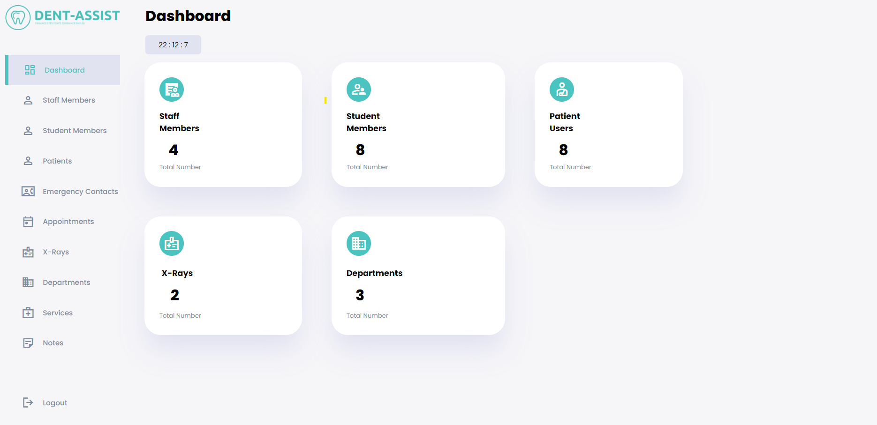

*Figure 1: Admin Dashboard*

Staff Interface: The dental clinic staff is taken care of via the staff interface. It gives them the resources they need to manage the patients, appointments, and other staff-related duties that have been assigned or made available to them. The user interface enables employees to see patient records, modify appointment statuses, and carry out important job-related tasks.

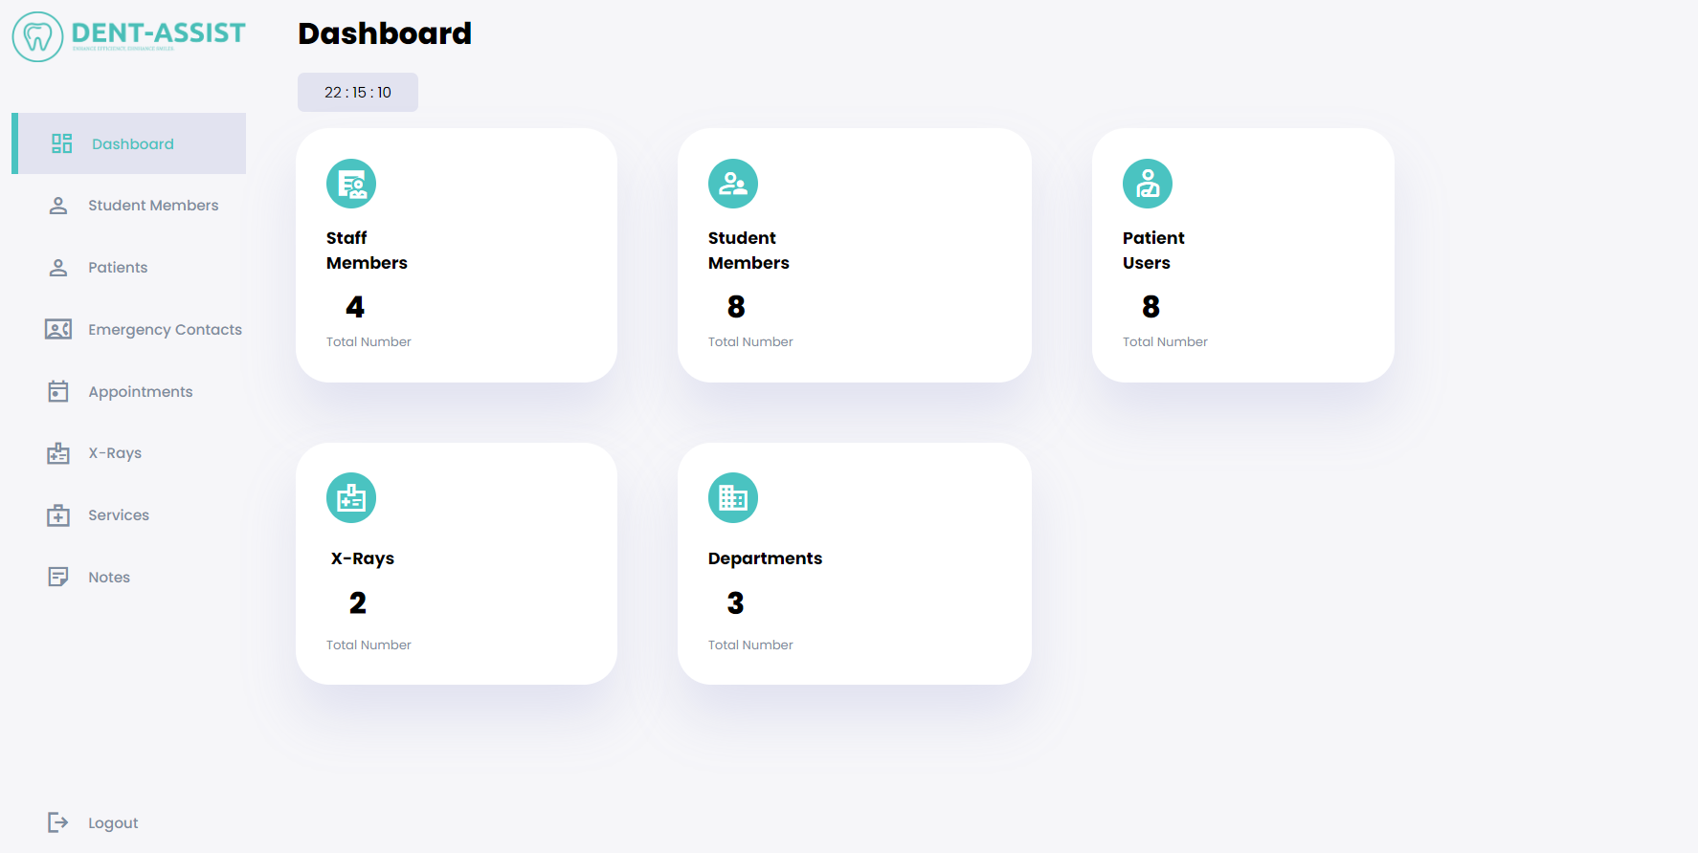

*Figure 2: Staff Interface*

Student Interface: The main goal of the student interface is to provide to students all the services they need to access. They get restricted access to patient data and appointment calendars thanks to it.

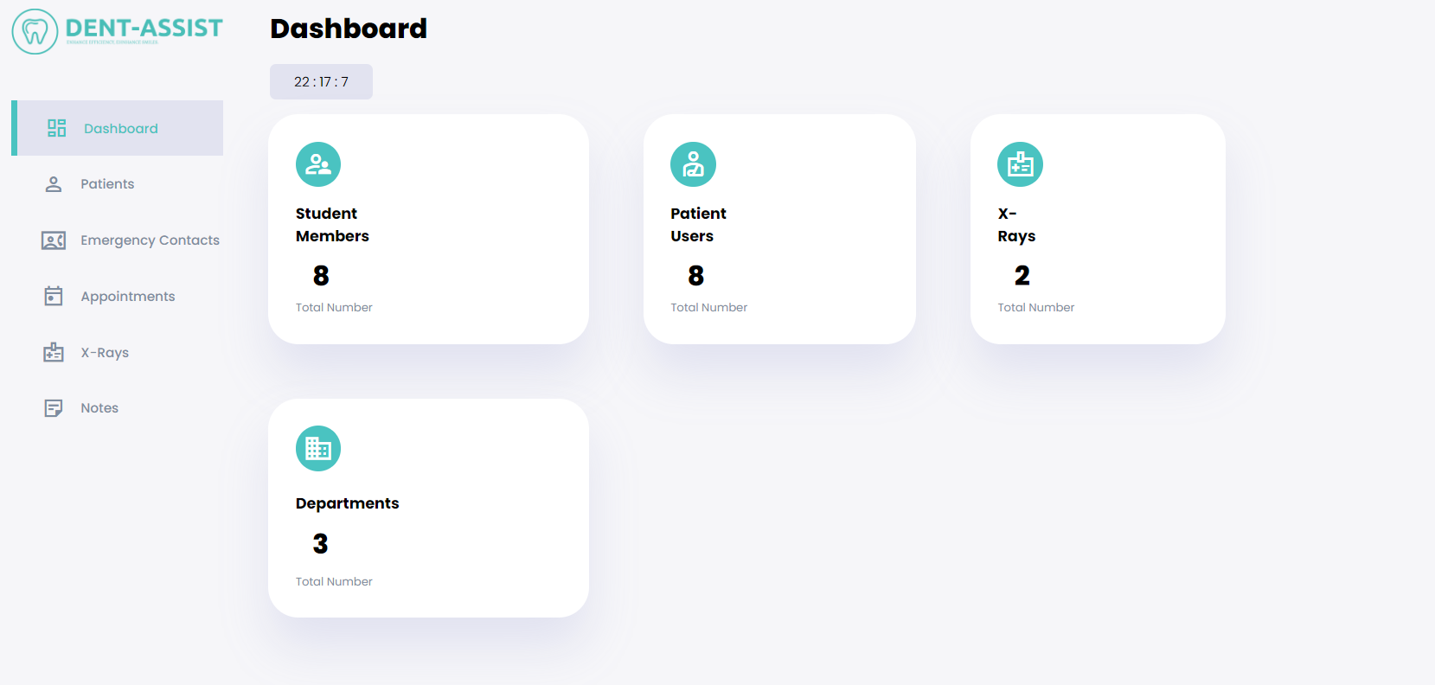

*Figure 3: Student Interface*

Patient Interface: The goal for the patient interface was to make it as easy as possible for patient users to access the web application. The web application is available to patients, who can use it to schedule appointments as well as view possible services that are offered by the clinic. To improve the patient's experience, the interface places a strong emphasis on clarity, easy navigation, and simplicity.

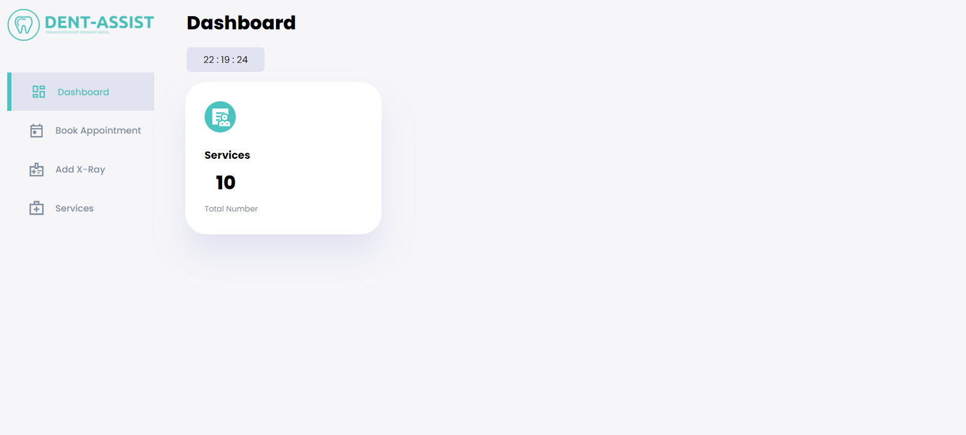

*Figure 4: Patient Interface*

**3.2 Hardware Interfaces**

This PHP based web application was created with the aim of being used in multiple devices, be them laptops, PCs, any type or version of smartphone or even tablets. The interfaces are also supportable by many browsers such as Chrome, Safari, Firefox, Microsoft Edge etc.

User input and output are the main ways that physical components and software interact. Keyboards, mice, touchscreens, and other pointing devices are used by users to interact with the application. When input is processed, the system displays the relevant output on monitors, screens, or mobile device screens.

Through the network, the web application communicates with hardware parts utilizing accepted communication protocols. Between the client (user's device) and the server hosting the program, data is often transferred using HTTP (Hypertext Transfer Protocol) or its secure variant, HTTPS.

**3.3 Software Interfaces**

To store and retrieve numerous data items, including patient records, appointment information, staff information, services, and system configurations, the web application interfaces with a MySQL database system. The application's data is stored persistently in the database, and the interface makes it easy to retrieve, store, and manipulate data. As mentioned above, the web application can be accessed through different operating systems as it is supported. For programming languages, this system has made use of PHP, HTML, CSS and JavaScript. The XAMPP must be installed in the local machine in order to facilitate a connection with the APACHE server and MySQL database.

**4. System Features & Functional Requirements**

**4.1 Development Model**

In general, our team has decided to adopt the Waterfall Model for the development of this software. Nonetheless, there are many times throughout the development process in which requirements may change or modifications have to be done for the system to provide a better experience. As a result of this, many aspects of Agile Development will be present as well. The main reasons for choosing the Waterfall Model are as follows:

Well-defined and clear planning: As the work for the project is organized in groups, it is essential to have milestones that are well-defined and easily understandable by all members. This can make project planning and the management of deadlines and timelines easier.

Documentation: As the experience of the team members with previous projects in the field of software development is limited, an emphasis on documentation guarantees that there is a better understanding of the requirements, design, and implementation as well during the process.

Linear development process: When applying the Waterfall Model, it is easier to understand what needs to be done and when. This also helps us determine if the tasks that are finished need improvement or changes when that process is finished.

Teamwork: When roles and responsibilities are made clear, the division of work within a team produces better results. In this case, each phase of the development process is completed before moving to the next one, and this allows each member to have a better view and understanding of their role.

Detection of issues early on: Since everything in the development process is performed in a step-by-step manner when problems arise it is easier to witness and improve them early on than to deal with delays or other similar issues.

Minimal involvement of the customer: Sometimes, it is not easy to maintain constant communication with the customer, so the requirements should be specified since the beginning together with the input and feedback during the requirements gathering phase.

**4.2 Functional Requirements**

The system must have a landing page which will display all the possible login or signup opportunities for all users: admin, patient, student, staff.

The system must only allow the patients to signup as staff members and dental students must be added by admin users, while students can also be added by staff users.

The system must allow the admin to possess all the functionalities that the other users can perform without exception.

The system must facilitate a different interface for each user, with a side panel that contains all the possible routes and alternatives and a dashboard which displays some data from the system and database.

The system must provide a constant connection to a database which will store all the different types of information.

The system should always display the names of the referenced foreign keys to have some meaning, although in the database they are simply stored as IDs.

The system must always have as the first column of relational database table the primary key of that table, through which this table can be referenced in other relations.

The system should display at the end of the side bar a logout icon which will allow each user to go back to the landing page, giving them the opportunity to log back in again even as another user.

The system should allow the login even through a username and even through a password, leaving it to the preference of the user.

The system should display in the dashboard of each user the total number of entries for the selected entities.

The system should allow the admin users to view, add, edit or delete staff members, students, patients, services, departments, appointments, x-rays, notes or emergency contacts.

The system should allow the staff to view, add, edit or delete students, patients, appointments, x-rays, notes or emergency contacts.

The system should allow the student to view patient and emergency contact details, as well as notes and x-rays but not edit them.

**5. Nonfunctional and Other Requirements**

**5.1 Nonfunctional Requirements**

The system should be secure and protect patient data privacy.

The system should be reliable and available 24/7.

The system should be responsive and fast, with minimal loading times.

The system should be easy to use, with a simple and intuitive user interface.

The system should be compatible with different operating systems and devices.

**5.2 Domain Requirements**

The system should comply with the regulations and standards of the healthcare industry.

The system should allow for the scheduling of multiple appointments over some time, such as for a complex treatment plan.

1. **Software Design & Modeling**

The purpose of this document is to present an abstract development of some models of the system, each one representing some different views and perspectives of the system. These system models are used to understand the functionality of the system as well as to communicate with customers. We will be working with models for a new system as there is not an existing one, and these models will be used to help explain the proposed requirements to other system stakeholders.

In this document, some graphical models are displayed with the purpose of facilitating more discussion about a proposed system, documenting some existing ideas about the system and generating a more detailed description that can be used to generate a system implementation.

*Context Model*

A context diagram is a high-level view of a system. It’s a basic sketch meant to define an entity based on its scope, boundaries, and relation to external components like stakeholders. As we have also specified in the previous parts of the project, in this system we will not be relying on other systems to process or gather data, therefore outside the system boundaries, we can see the stakeholders.

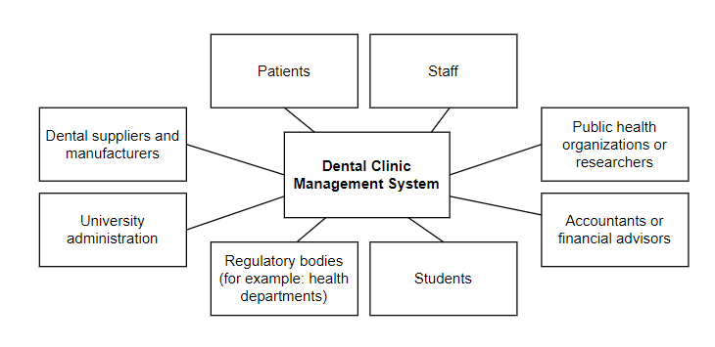

*Activity Diagram*

The activity diagram depicts the process flow of a patient visiting a dental clinic, from logging in to the system, scheduling an appointment with a dentist, and being notified of upcoming dental treatment. The diagram shows the different activities and decision points involved in the process, such as checking dentist availability, selecting the time dentist, and confirming the appointment. It also illustrates the flow of information between the patient, the clinic, and the dentist, as well as the roles and responsibilities of the different stakeholders in the process. Overall, the activity diagram provides a clear and visual representation of the steps involved in the clinic's appointment scheduling and treatment process.

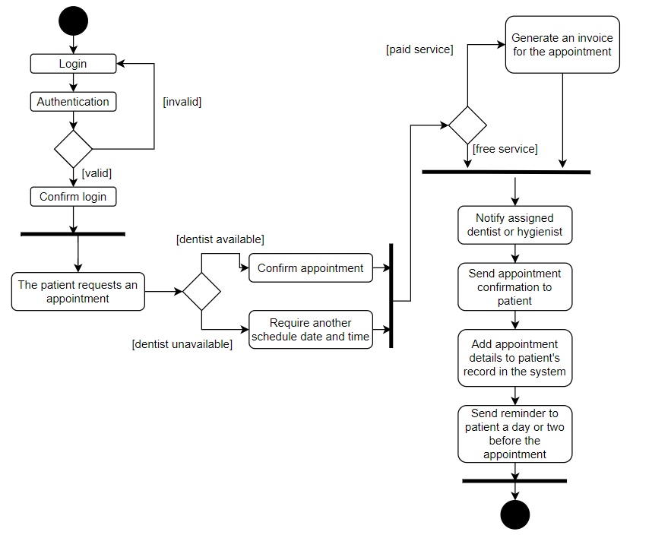

*Use Case Diagram*

The use case diagram represents the various actions that can be performed by different actors in the dental clinic management system. The actors include the patient, the staff, the student, and the administrator. Each of these use cases has different functionalities and is associated with different actors. The use case diagram provides an overview of the functionalities of the system and the interactions between the actors and the system.

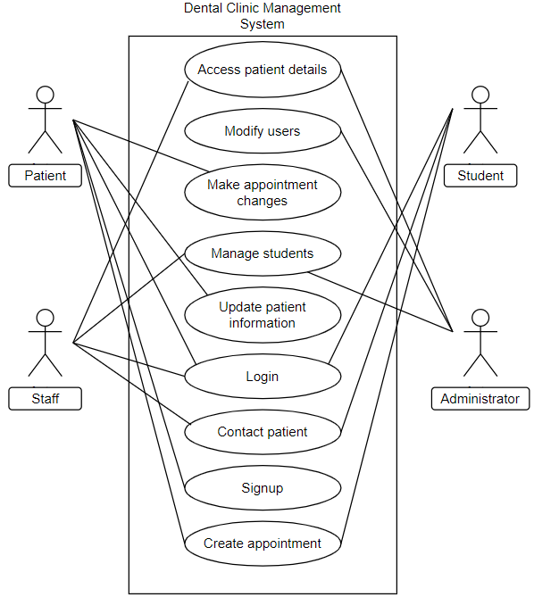

*Sequence Diagram*

Sequence diagrams are the most commonly used interaction diagrams, which show the interactive behavior of a system. When we use sequence diagrams, we depict the interaction between objects in the order in which these interactions take place, therefore sequentially. We use these diagrams to explain and describe in what order and how the objects in a system function.

These diagrams contain notations such as actors, lifelines, messages and guards. Actors represent types of roles where they interact with the system and the objects of the system, yet these actors are always located outside of the scope of the system being modeled. A lifeline is a named element which depicts an individual participant in a sequence diagram, meaning that each instance in a sequence diagram is represented by a lifeline. Messages are used to depict communication between objects and they appear sequentially along the lifeline.

In this sequence diagram we have one actor which is the admin of the system. As we can also see from the diagram the admin has the right to manage patients, staff and students which are all users of the system. For each of these users the admin can view, edit, add another user or delete an entity.

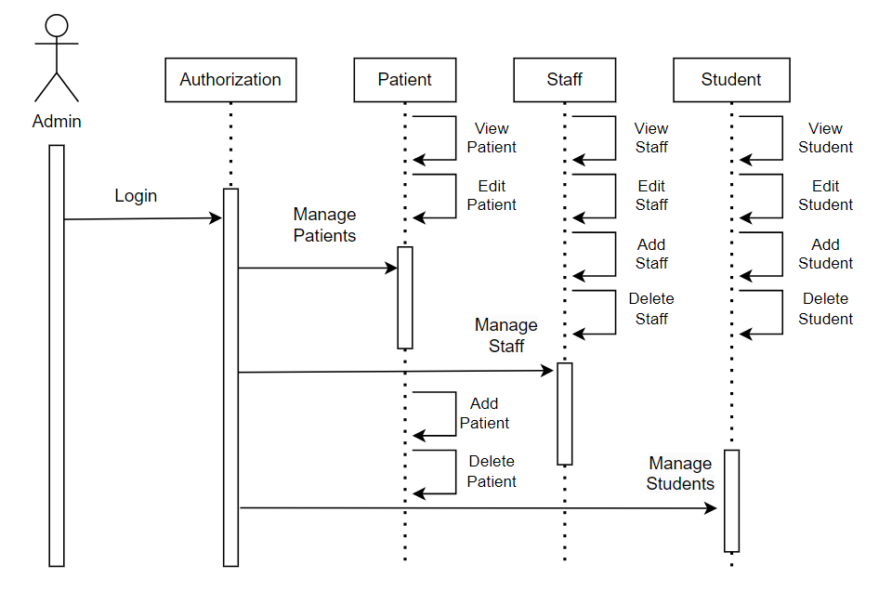

1. **Software Maintenance and Evolution**

Apart from a large investment on establishing a coherent, functional and responsive software system, it is necessary to allocate additional funds to upgrading, maintaining and evolving the system in order to constantly meet the ever-changing business requirements.

*Software evolution*

The process of developing new software never stops throughout the duration of a system. It continues even after a customer receives and deploys the product. The software of today is never complete. It must continuously develop to live up to user expectations if it is to continue to be helpful. Companies must make investments in a system update if they want to sustain the system's value and remain competitive. The software development life cycle will inevitably include a request for an enhancement. The causes of software evolution and maintenance include shifting business needs, software flaws, and updates made to various systems within the same software environment.

*Software maintenance*

After a software system has been delivered to the client, it can still be modified and updated. This process is known as software maintenance. Bug corrections, new feature additions, performance enhancements, and software updates that make it compatible with new hardware and software platforms can all fall under this category. Software maintenance is a way of preserving the software system's accuracy, effectiveness, and security while making sure it continues to meet user demands.

*Importance*

By making suggestions for enhancements and resolving current problems, it keeps the product current failure-free and continuously monitors the performance operations. The system's features and ease of use are enhanced by an upgrade.

*Factors to consider for dental clinic software evolution*

1. New Requirements

New methods of treatment by the clinic need to be added.

New emerging technologies and devices entering the market so the software has to be compatible with.

1. Business environment change

New marketing strategy which will be reflected on the web page design and information represented.

New hardware implemented and consequently new configurations has to be made.

Interfacing with partner software systems.

1. Errors

Finding and debugging errors.

1. Performance, reliability need improvement

Increase in number of patients consequently increases the data stored and the need for a new data storage structure.

*Potential changes to our application*

* Adding a feedback or rating session.
* Credit card payment through website.
* Instant messaging between patient and dentist.
* Private patient historical data session accessed only by the patient and relevant dentist.
* Patient reminders for upcoming appointments.

1. **Software Testing**

Software testing is essential for making sure the dental clinic management system software is of high quality, trustworthy, and functional. Various testing procedures and techniques are used throughout the development process to find and fix potential flaws, faults, and vulnerabilities. Testing in our case has been done incrementally, each time a new piece of code was implemented. Team members ensured that whenever a new functionality was added to the system many test cases with sample data and scenarios were done to make sure everything was working properly.

1. **Division of Work**

This document and project are the product of a team with five members: Ania Keci, Belita Hysaj, Idi Xhengo, Klea Lala and Renis Garxenaj. Ania Keci completed the code for the dental clinic management system and contributed with the initial idea of the system and technical side. Belita Hysaj organized the functional and nonfunctional requirements as well as the purpose, document convention of the introduction. Idi Xhengo prepared and structured the Software Maintenance & Evolution as well as the external interface requirements. Klea Lala prepared the System Design and Modeling while also assisting with the overall description. Renis Garxenaj constantly assisted with software testing, prepared the product scope as well as the intended audience and reading suggestions.

1. **References**

Software Template: <https://krazytech.com/projects/sample-software-requirements-specificationsrs-report-airline-database>

Interface Components: <https://www.tutorsglobe.com/homework-help/software-engineering/components-of-the-srs-7746.aspx#:~:text=The%20various%20design%20constraints%20are,and%20specify%20all%20such%20constraints>

Book: SOFTWARE ENGINEERING, Ninth Edition, Ian Sommerville

System Modeling Reference Websites:

<https://www.geeksforgeeks.org/unified-modeling-language-uml-sequence-diagrams/>

<https://www.geeksforgeeks.org/unified-modeling-language-uml-sequence-diagrams/>